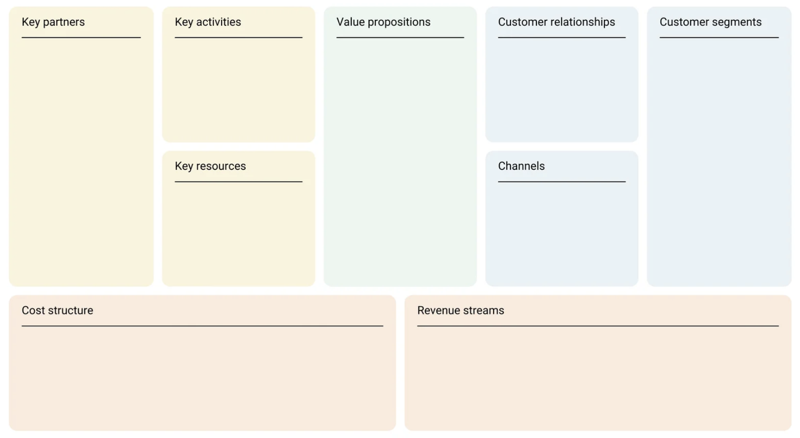

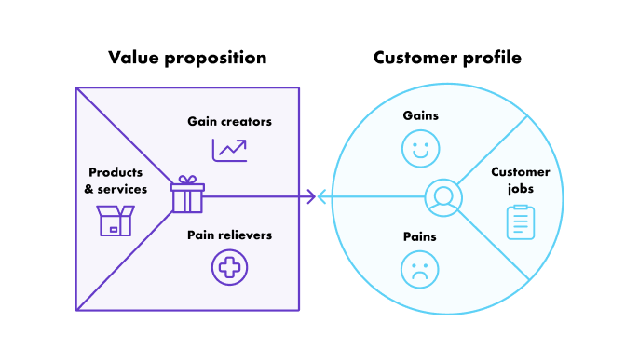

Value proposition: Saas (Software as a service) fast and easy to use to create an e-commerce that satisfies all of the customer needs.

Customer segments: independent and commercial retailers.

Customer profile:

* Customer Jobs:
  + Functional jobs:
    - want to sell something
    - set up domain
    - set up payment provider
    - set up shipping settings
    - set up taxes
    - manage the marketing side
    - IT maintenance
  + Social jobs:
    - reach a large audience
    - look appealing on the internet
    - improve and grow a social network
    - perceived as competent
  + Emotional jobs:
    - feel qualified
    - feel up-to-date

* Gains:
  + easy to use
  + easy to update
  + marketing support
  + customer support
  + appealing website
  + organization
  + communication
* Pains:
  + pay monthly for every little thing
  + less customizability
  + no email hosting
  + not having protection from frauds

Value proposition:

* Gain creators:
  + user friendly
  + easily reachable (only need a computer and internet connection)
  + always available customer service (h24)
  + free trial (14 days)
  + management of SEO
* Pain Relievers:
  + 15 free templates
  + more than 100 professional pre-made templates available
  + assured security (free from additional fees)
  + email forwarding is possible
* Products and services:
  + Shopify website that allows the customer to create their own e-commerce
  + Shopify app
  + Shopify POS (point of sales)

COMMENT:

Shopify Inc. is a Canadian multinational [e-commerce](https://en.wikipedia.org/wiki/E-commerce) company headquartered in [Ottawa](https://en.wikipedia.org/wiki/Ottawa), [Ontario](https://en.wikipedia.org/wiki/Ontario). It is also the name of its proprietary [e-commerce](https://en.wikipedia.org/wiki/E-commerce) platform for online stores and [retail](https://en.wikipedia.org/wiki/Retail) [point-of-sale](https://en.wikipedia.org/wiki/Point-of-sale) systems. The Shopify platform offers online retailers a suite of services including payments, marketing, shipping and customer engagement tools.

**Customer Segments**

Shopify works for those people that identify themselves as independent or commercial retailers; meaning that it goes from people that want to sell handmade jewelry, to big companies that work in an international market. It provides its commercial ecommerce solutions to a number of high-profile businesses and organizations, including Google, the Los Angeles Lakers, Tesla, World Vision, The Herschel Supply Company, and Mozilla. It works mainly in North America but as an online business it serves a global customer base.

**Customer Relationships**

Shopify operates principally as a self-service business. Customers are able to set up an account, design and operate an online store, subscription fees, manage inventory, and process payments online without the direct assistance of Shopify employees.

Shopify provides 24/7 assistance to its customers, which can be reached anytime over the phone, by email, or via an online chat service. The Company additionally offers a wide range of online resources, including user guides, FAQs, video, and podcasts.

Shopify also manages online community forums that allow Shopify users to interact with one another, discuss common problems, share ideas, and collaborate on projects. The Company also operates several social media profiles – including with Facebook, Twitter, YouTube, Instagram, Pinterest, Google+, and Snapchat – through which it is able to publish company updates and interact directly with customers.

It also provides analytics and reports to review the store's recent activity, get insight into visitors, analyze the online store speed, and analyze the store's transactions.

**Channels**

Shopify operates as a website at www.shopify.com, through which it provides information about its platform, its functionality and tools, its pricing options, and commercial solutions. Shopify.com also works as the gateway to its ecommerce platform, which is accessible by customers that can register for through the homepage.

The main channel through which Shopify serves its customers is its ecommerce platform, which provides a range of tools and functions to suit a range of online stores, including: customisable storefronts, website building tools, website analytics, email marketing, and order fulfillment tools. Customers are able to select pricing plans and make payments online.

Another important channel used by Shopify is its mobile app, Shopify Mobile, that provides important features and is available both on iOS and Android devices.

**Key activities**

The Company's software allows merchants to manage their retail business across multiple sales channels, including online and mobile storefronts, social media storefronts, and physical retail outlets.

The Shopify platform offers users software development and mainly IT operations and maintenance (with a 24/7 support from shopify personnel). Other functionalities offered by the company are made available through its Shopify Mobile app for iOS and Android, which enables users to track and manage their business on the go, meaning that the user is able to monitor functionalities like marketing and sales of their company anywhere, anytime. Blogging is also a key activity for Shopify, that is kept updated and interesting for the online audience by its personnel.

**Key** **resources**

Shopify’s key resources are its technologies and intellectual properties, its online platform, its IT and communications infrastructure, its network of partners, its research and development facilities, and its employees.

Shopify provides hardware, like the easily usable infrastructures provided for the Shopify POS service, and software, like the Shopify app and website, that are used by customers searching for any kind of information.

A core resource is the personnel of the company that works 24h a day, 7 days a week to help its customers in the best way they can, and can be reached by going to the section “Shopify Help Center” of the website.

The customer can also enable a variety of payment methods, like Shopify Payments or services from a third-party provider, that can be of two different types: direct provider, that enables customers to complete their purchases directly online, and external provider, that requires the use of a checkout page to complete the order.

From a financial point of view, one of the most important resources has been the investment closed by Shopify in 2013, which was a $100 million Series C investment led by OMERS Ventures and Insight Venture Partners, with participation from Bessemer Venture Partners, FirstMark Capital, Georgian Partners, and Felicis Ventures.

Lastly, Shopify Multivendor Marketplace App is another key resource that lets the customer convert their store into a fully-functioning marketplace. Here, multiple sellers can register and sell their products locally or globally and the admin can charge a commission on each seller’s earnings.

**Key partners**

Shopify works in close collaboration with a network of partner companies and organizations, in order to ensure the reliability and usability of its platform. The Company has partnerships with several app developers like, Notably, Zapier, Langify, and Vantage.

In 2016, Shopify acquired Boltmade (a product design and development consultancy based in Waterloo, Ontario) and partnered with Paystack which allowed Nigerian online retailers to accept payments from customers around the world. Only one year later, in 2017, the company also announced the integration with Amazon that would allow merchants to sell on Amazon from their Shopify stores.

Another important cluster of partners of Shopify comprises payment gateways companies, which are essential to the functioning of the company that are, for example, PayPal, Facebook Pay, Amazon Pay, and Apple Pay.

**Value proposition**

Shopify is an extremely friendly platform and, even if you are not a web/software developer, or you don’t have the IT skills you need to create a website, it makes you able to open one.

It’s simply a combination of an e-commerce website hosting and building tool. To quote their website “Bring your business online: Create an ecommerce website backed by powerful tools that help you find customers, drive sales, and manage your day-to-day”

**Cost structure**

Shopify has its main costs from the development of its technologies and platform, the maintenance of its IT and communications infrastructure, the management of its partnerships, the procurement of services, the implementation of marketing and advertising campaigns, and the retention of its personnel. Also legal costs take a tool in the company, as well as the cost for maintaining the relationships created with partners.

**Revenue Stream**

The revenue streams come from monthly subscription fees paid by its community of users, that come in three tiers, each of which provides differing levels of functionality.

Subscriptions start out at $29 per month for a basic account, rising to $79 per month for a standard account, and to $299 per month for an advanced account. They also added two more options that enlarge the range of budget a company could have, we have the lite subscription which costs $9 a month and the Shopify Plus (in which the user can create its own commercial software) subscription that starts from $2000 a month.

Revenues also come from smaller changes made by the user, for example the cost of taking out the “myshopify.com”.

**Final Considerations**

Considering both the Business Model Canva and the Value Proposition Canva, even thought Shopify is a major player in e-commerce market, there is some space for improvements, for example we noticed that the monthly payments could be implemented by adding a yearly payment, also we noticed that the customer finds really annoying to be paying for every little thing in addition to the subscription fee, even in the advanced account, maybe simply rising the price would be enough to make the customer feel like it isn’t paying everything every month.

Also, something that could actually improve the customizability of the website could be adding some more specific features where one could change the actual code behind the elements supplied by Shopify.

**Facts and News**

The most important facts about Shopify are probably the ones regarding the stock market. Citing the “The Wall Street Journal” in the article “Canadian Software Company Shopify Files for U.S.-Canada IPO” by Maria Armental (last updated in 2015) Canadian software company Shopify Inc. filed for an initial public offering Tuesday in the U.S. and Canada in 2013. “According to the IPO filing, Shopify valued its shares at $10.72 each in March. That would put its valuation at about $713 million, based on the weighted average shares outstanding in March and excluding stock options.”

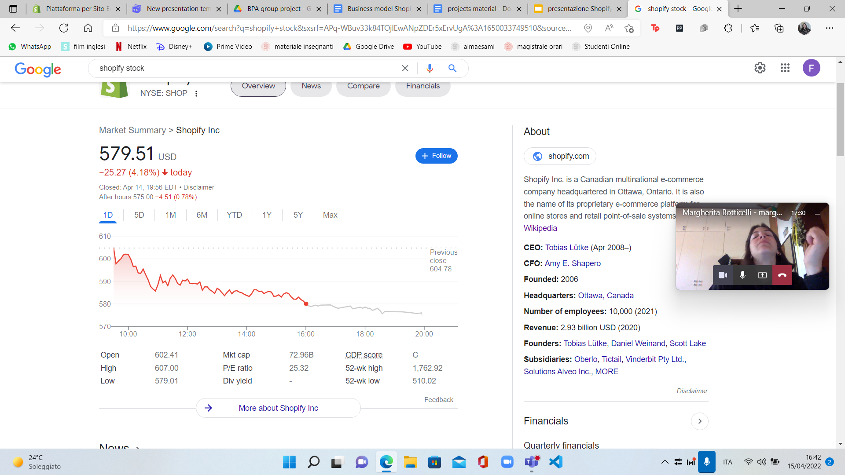

In the “Forbes” Website in 2021 Walter Loeb in the article “Shopify Sees 57% Revenue Growth As It Rolls Out New Pay And Shipping Features” stated: “I expect the company will continue its rapid growth through the acquisition of new clients since internet commerce has sustained momentum.” but, as recent research and outcomes show, this did not happen as in the Nasdaq publication “the company’s growth is slowing. Revenue for the full year of 2021 was $4,611.9 million, [a 57% increase over 2020](https://news.shopify.com/shopify-announces-fourth-quarter-and-full-year-2021-financial-results). While that may be impressive, the company finished with year-on-year growth of 86% in 2020 over 2019.” so as much as it is still growing and gaining it is slowing down keeping the stocks price down.

In fact, Nasdaq published on April 8th, 2022 the article “Shopify Stock Falls Over 50% But More Pain Is on the Way” where it states that “Shopify and other e-commerce companies in the space are facing tough year-on-year comparisons. Shopify soared during the latest pandemic that forced businesses to close up shop. The company tacked on $25 billion in only a few short years, and shareholders clamored for more! But once the hype wore off, investors realized the value of buying at a lower price point”.

To make some future predictions we leave with this final part of the above-mentioned article of Nasdaq: “Shopify’s profitability and valuation are poles apart at the moment. Although the company is growing, it is too richly valued. Management is predicting revenue growth will slow in 2022. The exact percentage decline isn’t specified…If Shopify’s stock continues to drop, it could be an opportunity. It has [launched a “Shopify Fulfillment Network,”](https://www.shopify.com/fulfillment) where companies can outsource their orders. Plus, Shopify currently has no digital ad business. That could be a major source of potential revenue. However, the current market is volatile, and Shopify still needs to fall further to reflect its fundamentals. Software providers with rich valuations are not in a great position.”